Name (as Gaeilge):
Name (English version if applicable):
Club Name (as Gaeilge)
Club Name (in English)

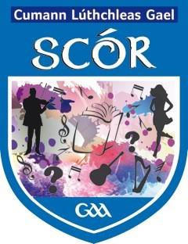
SCÓR PARENTAL/GUARDIAN CONSENT FORM FOR ALL PARTICIPANTS UNDER 18 YEARS OF AGE
GAA Membership Number
I/we agree to permit our child, , to participate in GAA SCÓR competitions and rehearsals under the supervision of nominated Club and Coiste Náisiúnta Scór personnel.

I also agree that my child may be photographed and that recording footage may be taken of them during their participation in Scór solely for use in the promotion of Scór and Cumann Lúthchleas Gael activities.

YES NO

Participant’s Name: ---------------------------------------------

Participant’s Date of Birth: _ _ / _ _ / _ _

Does your child suffer from any allergies or medical conditions? YES / NO
If YES please state:

Medication: Is your child taking any prescribed/non prescribed medication?
If YES please state:

If your child requires any of this medication during their attendance and participation in Scór please inform one of the team mentors.

Note: GAA nominated personnel shall keep emergency medication of underage participants in a safe and accessible place in accordance with the wishes and permission of parents/guardians. GAA personnel do not administer medication or medical aid to children unless they have received the necessary training to administer such aid and have also agreed to do so with their Club and or Coiste Náisiúnta Scór and the child’s parents/guardians.

If your child requires emergency medical aid, including admission to hospital, do you consent? YES NO

Parent / Guardian must inform the Club or Scór officials if their child’s medical needs change, after they have signed this form.

I understand that this information shall only be used for the purposes of participation in Scór, and may be retained by the GAA and only used for my child(rens) participation in Scór events.

Guardian Signature(s):
Emergency Contact Number(s):
Date:

